**User Stories and corresponding Story Points: -**

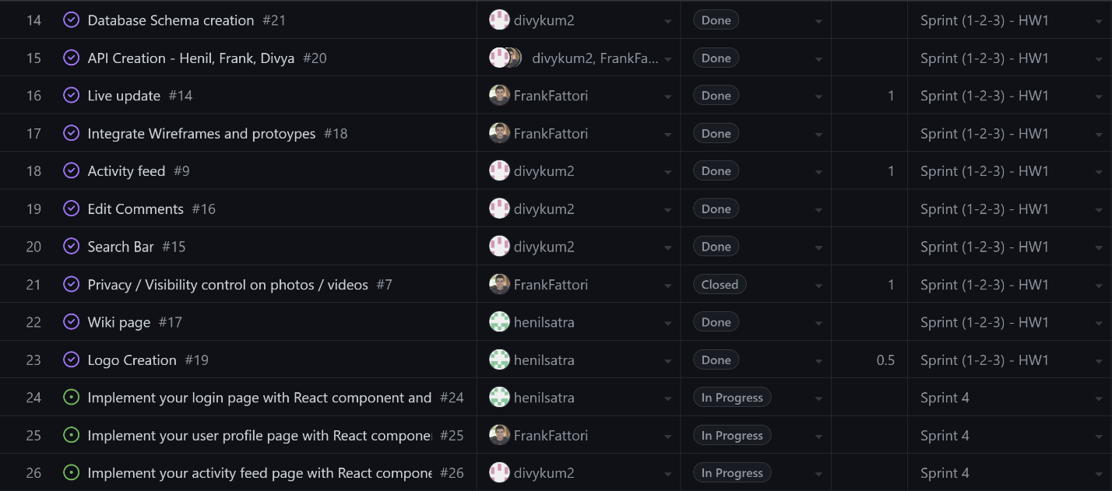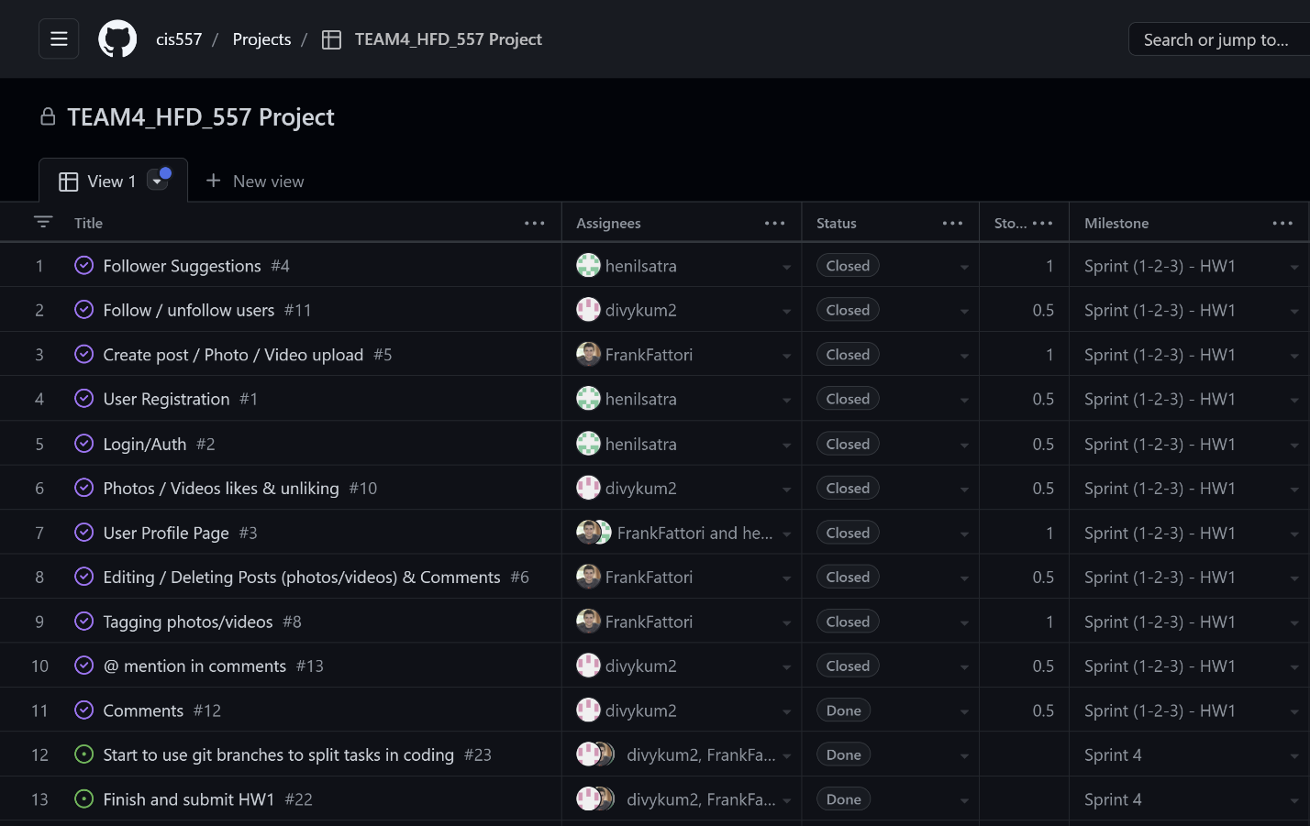

User Story explanation: -

1. Follower suggestion –

As a user (owner of account), I should get random follower suggestions who I can follow.

Acceptance: When I click on the follow button, I should be able to follow them/send them a request.

2) Follow/Unfollow users –

As a user (owner of account), I should be able to unfollow or follow people.

Acceptance: When I click on the follow button, I should be able to follow them/send them a request and if I am already following them, I should be able to unfollow them.

3) Create a post/ photo and video upload –

As a user (owner of account), I should be able to upload a photo/video, add a caption, tag people and even change the visibility settings.

Acceptance: When I click on the create a post button, I should be able open a window which allows me to browse a photo/ video, I should be able to type a caption, set visibility private or public, tag people by searching their name and finally upload the post to my feed by pressing the submit button.

4) User registration –

As a new user (owner of account), I should be able to create a new account by giving my email, setting a user id and creating a new password.

Acceptance: When I click on the sign-up button, I should be able to type my name, email address, user id and new password. Email id should be valid, user id should be unique, and password should be of at least 8 characters. Finally, on pressing the submit button, the account should be created, and I should be redirected to the login page.

5) Login –

As a user (owner of account), I should be able to login into my account by giving username/email and password.

Acceptance: When I click on the login button, I should be able to type email address/user id and password. Email id/user id should be valid, and password should be matching. Finally, on pressing the submit button, I should be redirected to the activity feed.

6) Like/unlike –

As a user (owner of account), I should be able to Like/unlike people’s posts.

Acceptance: When I click on the like button, I should be able to like the posts and if I have already liked it, I should be able to unlike it.

7) User Profile page –

As a user (owner of account), I should be able to see my followers, following, bio, posts and should be able to add a post/status.

As a follower, I should be able to see their followers, following, bio, posts.

Acceptance: Clear distinction between your profile and your followings profile page with relevant functionality.

8) Comment –

As a user (owner of account), I should be able to see comments, reply to them, make comments and edit them.

As a follower, I should be able to see their comments, make comments on their posts.

Acceptance: One should be able to make and edit a comment when one presses the comment button.

10) Search Bar and Live updates –

As a user (owner of account), I should be able to search people to follow them. I should get notifications when someone accepts my request or sends me a request or tags me.

Acceptance: Search bar should send results as per character inputs and notifications should be real time live updates.

11) Database and API creation on SwaggerHub –

As an admin, I should make my database schema and my GET, POST, DELETE and UPDATE requests and APIs on SwaggerHub

Acceptance: Implementation should be error free and in working condition after testing.

12) Wireframe creation –

As an admin, I should make wireframes for UI of every page with every component. I should link the wireframes aswell.

Acceptance: Implementation should be error free and in working condition after testing.

13) Wiki Page –

As an admin, I should make a wiki page explaining my project and its different components

Acceptance: All the topics should be covered.

14) Logo creation –

As an admin, I should create a logo for my project

Note : All other User stories are part of a broader User Story/ component.